Quantifying correlation

In-class investigation
Solutions and marking key

Question 1 (7 Marks)
 | Solution | Mathematical behaviours | Marks
(a) | 10 | - reads number of points on scatter graph | 1
(b) | 6 | - reads position of horizontal median line | 1
(c) | 8 | - reads position of vertical median line | 1
(d) | 3 in quadrant A | - interprets values on scatter graph  - identifies location of points | 1  1
(e) | q-correlation coefficient  = (3 + 3 - 2) ÷8  = $\frac{4}{8}$  = 0.5 | - reads number of points on scatter graph  - calculates q-correlation coefficient  ($\frac{1}{2}$for fraction, $\frac{1}{2}$for decimal) | 1  1

Question 2 (7 Marks)
 | Solution | Mathematical behaviours | Marks
(a) | As the temperature rises the number of pies sold decreases | - interprets scatter graph | 1
(b) | 70 | - reads position of horizontal median line | 1
(c) | There are no days where the temperature was 24 nor where the number of pies sold was 70 | - identifies median not a score for temperature  - identifies median not a score for pies sold | 1  1
(d) | q-correlation coefficient  = )(0 + 0) – (5 + 5)) ÷ 10  = -1 | - reads number of points on scatter graph  - calculates q-correlation coefficient | 1  1
(e) | 1 | - interprets calculation of q-correlation coefficient | 1

Question 3 (8 Marks)
 | Solution | Mathematical behaviours | Marks
(a) | 10% | - reads scatter graph | 1
(b) | 90% | - reads scatter graph | 1
(c) | The class in which 50% liked soccer and 50% liked football. | - interprets scatter graph  - describes both variables | 1  1
(d) | q-correlation coefficient  = ((2 + 2 – (2+2)) ÷8 = 0 | - reads number of points on graph  - calculates q-correlation coefficient | 1  1
(e) | No relationship. The points are scattered randomly. | - Describes lack of relationship  - interprets scatter graph | 1  1

Question 4(a)(d)(e)(f) Q4=7 Marks
Solution
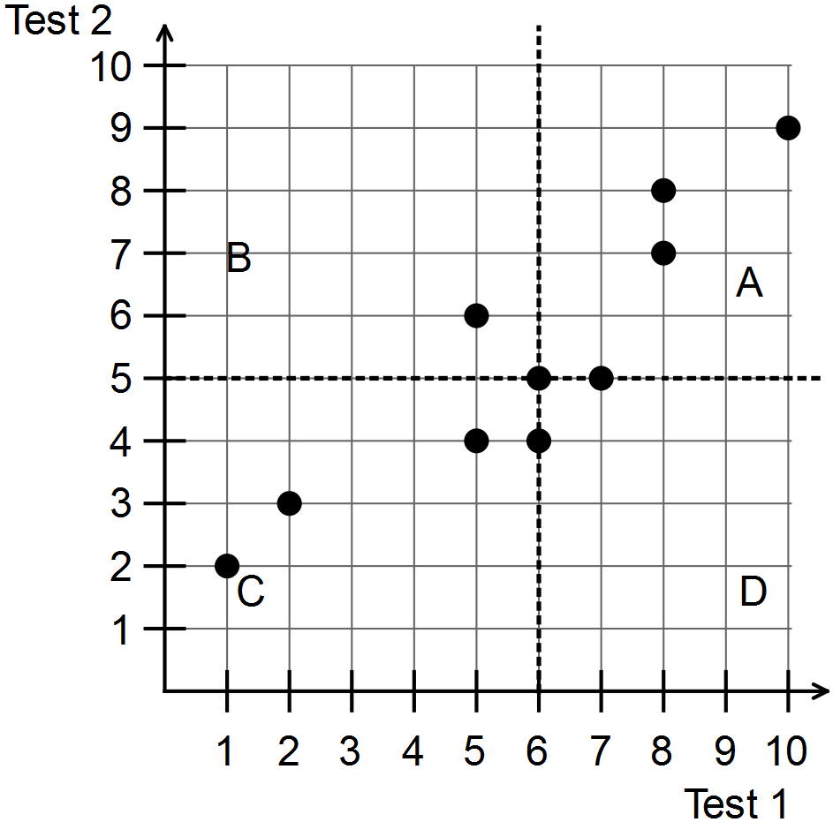

Mathematical behaviours | Marks
- plots most points accurately  - plots all points accurately  - draws vertical line at median for Test 1  - draws horizontal line for median at Test 2  - labels quadrants as previously instructed | 1  1  1  1  1

Question 4(b)
Solution
Median = 6
Mathematical behaviours | Marks
- calculates median | 1

Question 4(c)
Solution
Median = 5
Mathematical behaviours | Marks
- calculates median | 1

Question 5(a) Q5=12 Marks
Solution
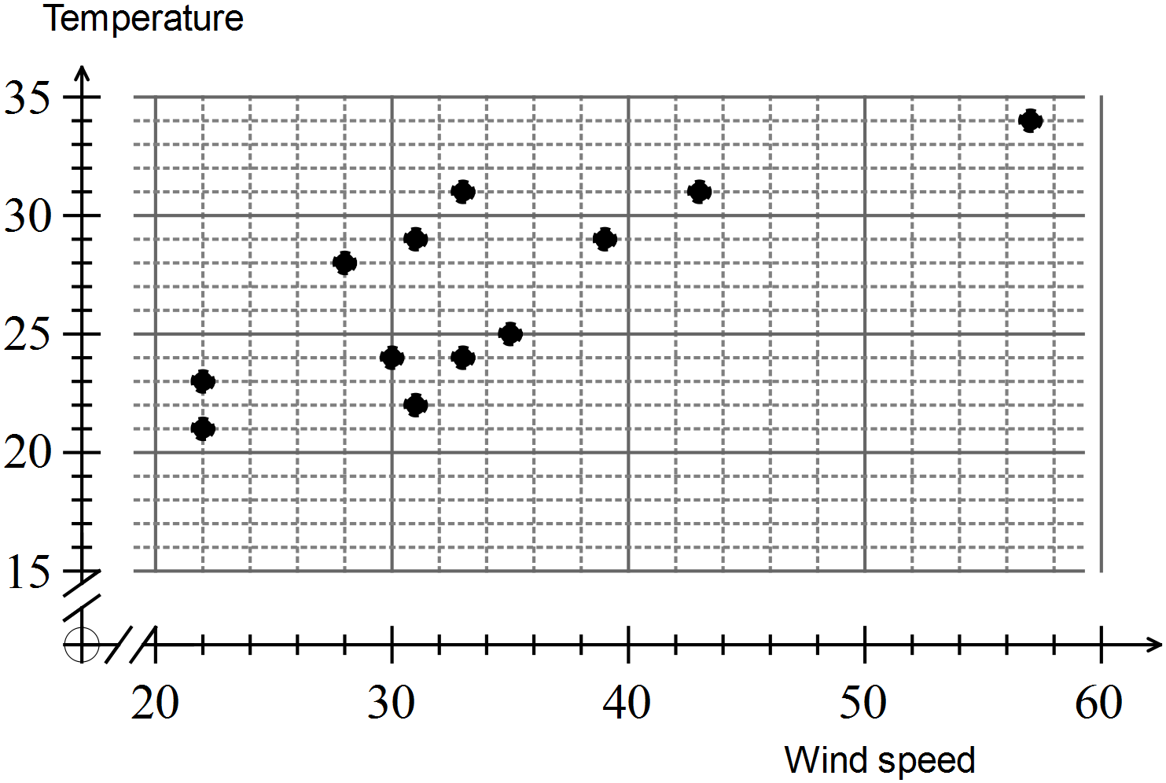
Mathematical behaviours | Marks
- plots coordinates for each point in correct order  - plots most points accurately  - plots all points accurately | 1  1  1

Question 5(b)
Solution
As wind speed increases so does the temperature; the points are generally rising to the right
Mathematical behaviours | Marks
- notes increasing wind speed is associated with increasing temperature  - describes location of points | 2  1

Question 5(c)
Solution
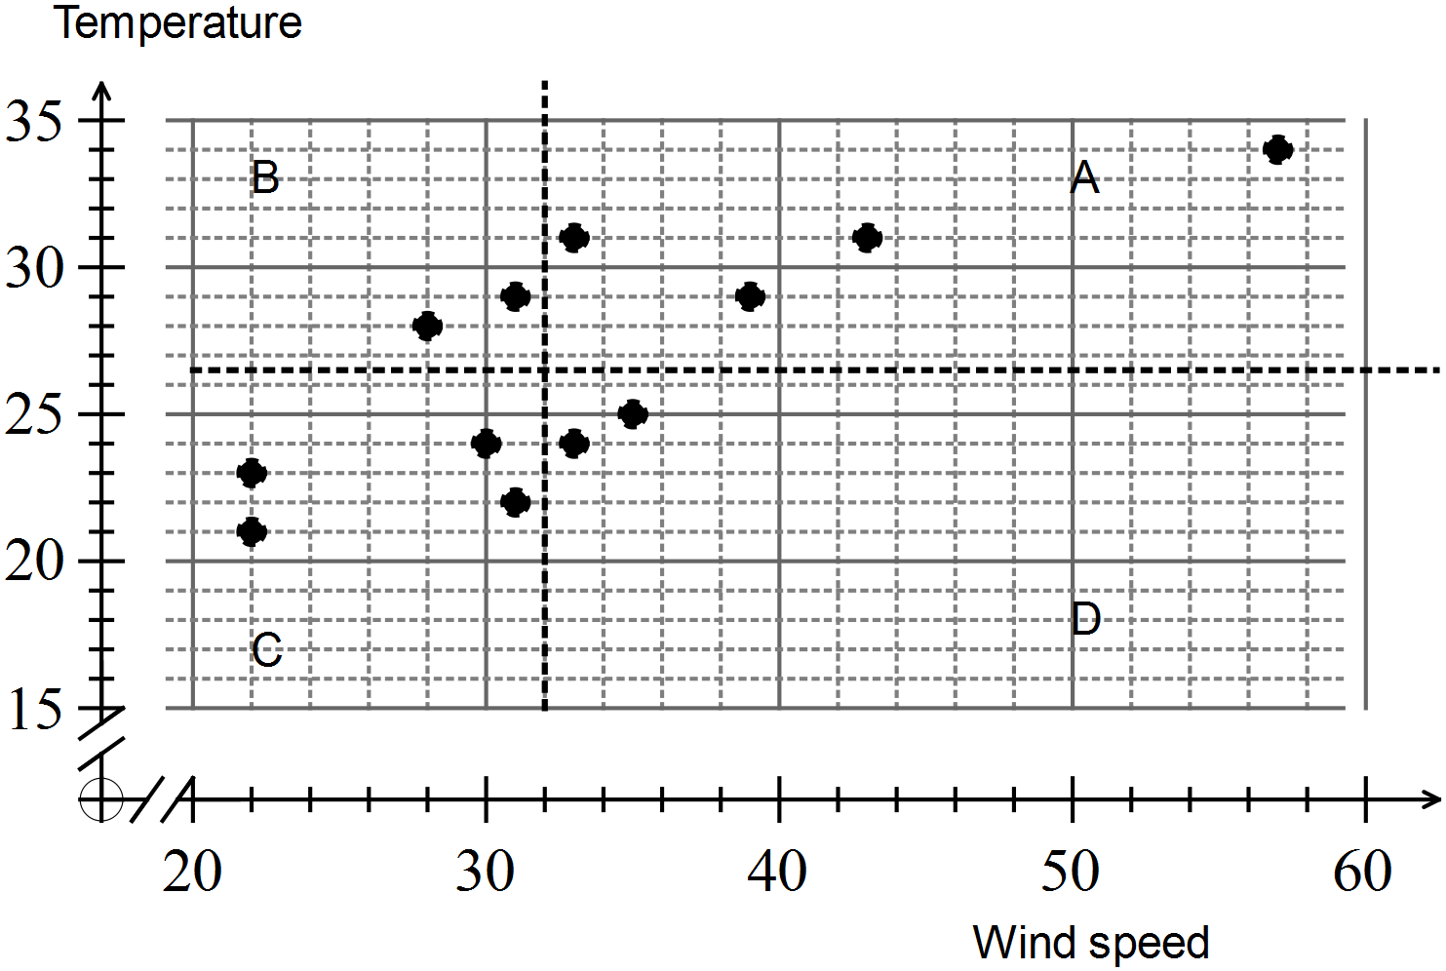
Mathematical behaviours | Marks
- determines median maximum wind speed  - determines median maximum temperature  - draws median lines and labels quadrants | 1  1  2
Question 5(d)
Solution
q-correlation coefficient = (8 - 4) ÷ 12 = $\frac{1}{3}$ = $0.3\dot{3}$
Mathematical behaviours | Marks
- determines number of points in each quadrant  - calculates the q-correlation coefficient ($\frac{1}{2}$for fraction, $\frac{1}{2}$for decimal) | 1  1

Question 6 (9 Marks)
 | Solution | Mathematical behaviours | Marks
(a) | (i) 0.9  (ii) 0.1  (iii) -0.6  (iv) 0.1  (v) 0.9  (vi) -1 | - identifies positive correlation from graph  - identifies lack of relationship from graph  - identifies negative correlation from graph  - identifies lack of correlation from description  - identifies positive correlation from description  - identifies negative correlation from description | 1  1  1  1  1  1
(b) | Easy to follow/calculate  More precise than guessing | - suggests one advantage | 1
(c) | Inaccurate  Time-consuming | - suggests disadvantage of the process  - suggests disadvantage of the process | 1  1

